Understanding the Efficiency Bar Graph

The report date is printed here.

Green = 100%

Blue indicates that a writer has worked above 100%

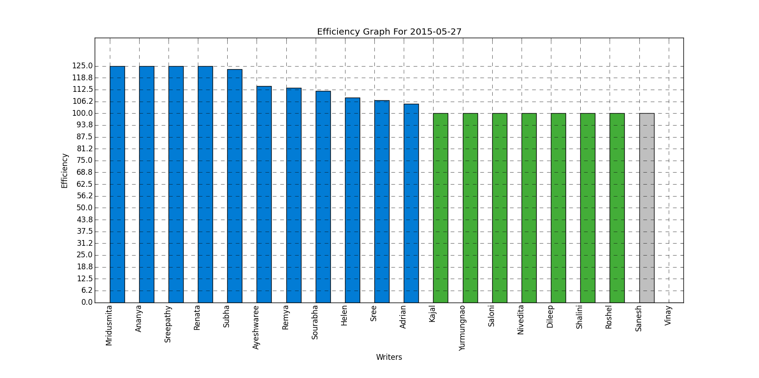

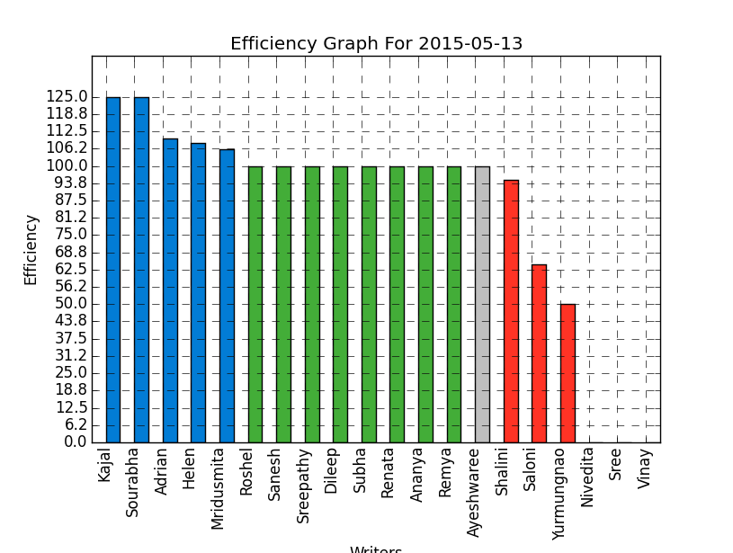

Writer names are indicated here, ranked according to efficiency.

Writers whose efficiency is displayed in grey are on a planned leave.

Red indicates that a writer has worked below 100% efficiency.

Understanding the Quality Bar Graph

Red indicates below 95% quality.

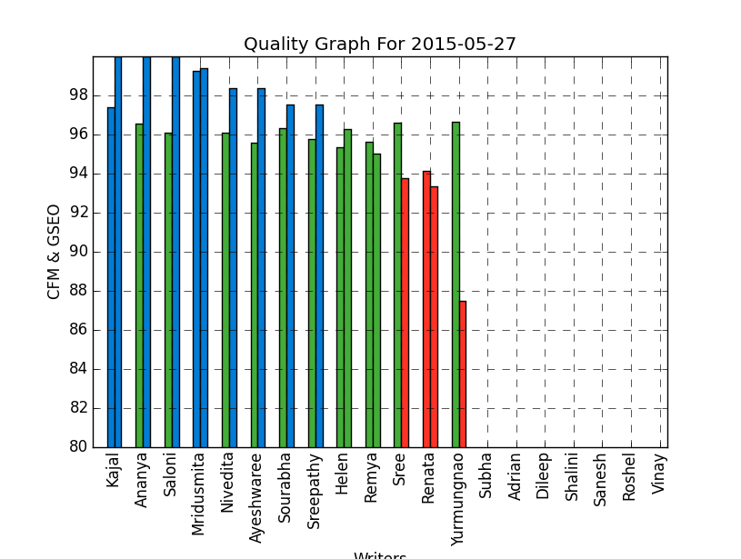

The second vertical bar indicates the average GSEO score for a date for each writer.

The first vertical bar represents the average CFM score for a date for each date.

Blue indicates a quality of above 97%

Green indicates 95% to 97% quality.